HTML and CSS3 Material

Introduction to HTML
HTML Stands for Hyper Text Markup Language
HTML used to develop static web pages
Current version of HTML is HTML5.X
HTML Released by "Tim Berners Lee" in 1991
we will execute HTML with the help of "Browsers" Ex.
Google Chrome Mozilla
Opera IE
Safari
Netscape Navigator
IDE is used to develop the software applications Ex.
Notepad Edit Plus Notepad++
Visual Studio Code Eclipse
Visual Studio Code is Recommended IDE to develop web applications
Visual Studio Code provided by "Microsoft" and "open-source IDE"
CSS Stands for Cascading Style Sheet
CSS used to apply styles to web pages Ex.
color
background-color margin
padding border
border-radius
Current version of CSS is CSS3.X
Extension of CSS files is ".CSS"
JavaScript is the Scripting Language
JavaScript used to develop Dynamic Web Pages
JavaScript also used to implement the Forms Validations
Current version of JavaScript is ES13
ES Stands for ECMA Script
Extension for JavaScript files is ".js"

HTML is TAG Based Markup Language Ex.
<table></table>
<h1></h1>
<a></a>
<br>
<img>
<p></p>
<title></title>
<head></head>
TAGS Divided into two types
container/paired tags
non container tags/non paired tags
container/paired tags contains both opening and closing tag
non container tags/non paired tags contain only opening tag
closing tag should contain "/"
combination of opening tag, content and closing tag called as HTML Element
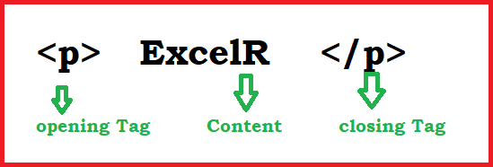

Attributes enhances html element functionality
Attributes are key and value pairs
key and value separated by using "="
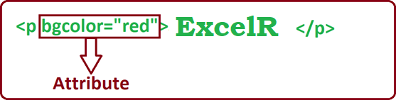
Features of HTML5.X
WebSocket
WebSocket used to implement the chat applications WebSocket available in HTML5.X

Web Worker
Web Worker used to run JavaScript in Background Web Worker also available in HTML5.X
Storages API
HTML5.X Supports two types of Storages
Local Storage
Session Storage
whenever we close the browser/opens the new tab we won’t lost the data from Local Storage
whenever we close the browser/opens the new tab we will lose the data from Session Storage
Geolocation API
it is used to find the current location of user/device Geolocation API also available in HTML5.X
Drag & Drop API
This API helps to Drag and Drop HTML Elements This API also available in HTML5.X
Semantic Elements
HTML5.X Released New Elements/Semantic Elements Semantic Elements increases application readability
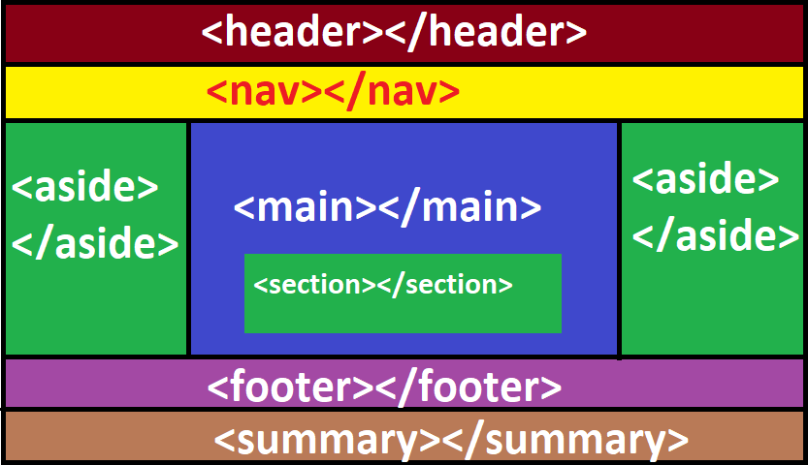
Ex.
<header></header> <nav></nav>
<main></main> <section></section> <footer></footer>
<summary></summary>
<audio></audio>

<video></video> Structure of Webpage DOCTYPE
ROOT SECTION
HEAD SECTION
METADATA BODY SECTION
MAIN CONTENT
DOCTYPE Representing version of HTML
Browsers only understands the DOCTYPE
Below DOCTYPE Representing HTML5.X
<!DOCTYPE html>
<html></html> tag used to create the ROOT SECTION
ROOT SECTION Divided into two sections
HEAD SECTION
BODY SECTION
<head></head> tag used to create the HEAD SECTION
<body></body> tag used to create the BODY SECTION
Data about webpage called as METADATA Ex.
Author Description Title
we will define METADATA under HEAD SECTION
we will define Main Content under BODY SECTION Ex.
Tables
Forms Headings Paragraphs Images
<!DOCTYPE html>
<html>
<head>
//METADATA
</head>
<body>
//MAIN CONTENT
</body>

</html>
Software Installation

download and install Visual Studio Code
Visual Studio Code is the IDE.
Visual Studio Code provided by "Microsoft" and "open source".
Visual Studio Code is "recommended" to develop "web applications"
website: https://code.visualstudio.com/docs/?dv=win file: VSCodeUserSetup-x64-1.77.3.exe
install Live Server plugin
Live Server plugin watches application changes
Live Server plugin gives "changes notification" to browser
browser will "reload/refresh" automatically
open the "VSCode" ==> Click "Extensions" ==> Search "Live Server" ==>Select "Live Server" ==> Click "install"
install "Dummy Text Generator" Plugin
"Dummy Text Generator" Plugin generates content randomly
open the "VSCode" ==> click "Extensions" ==> Search "Dummy Text Generator" ==> select "Dummy Text Generator" ==> click "install"
Enable "AutoSave" Settings
Application will save Automatically without "ctrl+s"
open the "VSCode" ==> click the "Manage" ==> click "settings"
==> choose "AutoSave" ==> select "afterDelay"
install browser
Google Chrome
Firefox
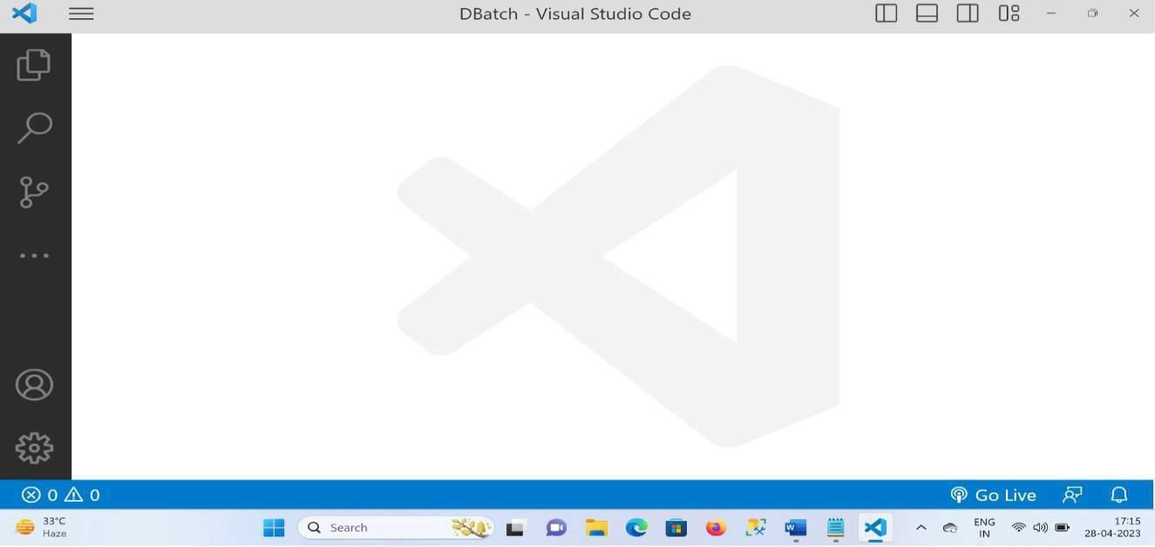

Headings in HTML
External CSS
Padding in CSS
Block Level Elements
Headings in HTML
HEADINGS

HTML Supports 6 types of Headings
<h1></h1> main heading
<h2></h2> sub heading
<h3></h3> ""
<h4></h4> ""
<h5></h5> ""
<h6></h6> ""
External CSS
<link> tag, used to include the external CSS file
<link> tag is non paired tag
<link> tag supports two attributes
href
rel
Padding
space around the content called as padding
Ex.
padding:20px;
Block Level Element
Block Level Elements Starts with new line
Headings are Example for Block Level Elements
headings.html
<!DOCTYPE html>
<html>
<head>
<title>Headings</title>
<link rel="stylesheet" href="headings.css">
</head>
<body>
<h1>ExcelR</h1>
<h2>ExcelR</h2>
<h3>ExcelR</h3>
<h4>ExcelR</h4>

<h5>ExcelR</h5>
<h6>ExcelR</h6>
</body>
</html>

headings.css
h1,h2,h3,h4,h5,h6{ color: red;
background-color: yellow; text-align: center; padding: 20px;
border: 1px solid red; width: 50%;
border-radius: 0px 60px;
box-shadow: 0px 0px 20px red;
}
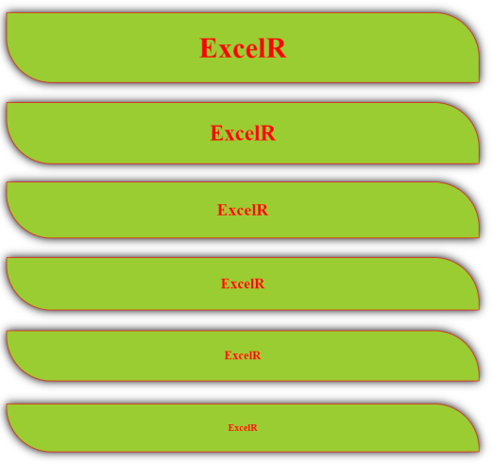
Text Formatting Tags
<b></b> bold text
<strong></strong> strong text
<i></i> italic text
<em></em> emphasized text
<u></u> underlined text
<del></del> deleted text
<strike></strike> strike text
<mark></mark> marked text
<sup></sup> superscript
<sub></sub> subscript
<big></big> big text
<small></small> small text
<code></code> represent the computer code
<var></var> mathematical formulas
<br> line break
<hr> horizontal line
<address></address> display address
<abbr></abbr> abirritations
title attribute used to define abbreviation
<bdo dir=""></bdo> bi directional override
<blockquote></blockquote> represent the quotations
Example
<!DOCTYPE html>
<html>
<head>
<title>Text Formatting Tags</title>
</head>
<body>
This is <b>Bold</b> Text <br>
This is <strong>strong</strong> text <br> This is <i>Italic</i> Text <br>
This is <em>Emphasized</em> Text <br> This is <u>underlined</u> Text <br>
This is <del>Deleted</del> Text <br> This is <strike>Striked</strike> Text <br>

This is <mark>Marked</mark> Text <br> a<sup>2</sup>+b<sup>2</sup> <br> H<sub>2</sub>O <br>
This is <big>Big</big> Text <br>
This is <small>small</small> Text <br>
<code>for (int i=0; i<10; i++) {} </code> <br>
<var>a2+b2</var> <br>
<hr>
<address>
ExcelR <br>Ameerpet
<br> Hyderabad
</address>
<br>
<abbr title="Hyper Text Markup Language"> HTML
</abbr>
<br>
<bdo dir="rtl">Welcome to UI Technologies</bdo>
<br>
<blockquote>
Stay Home Stay Safe
</blockquote>
</body>
</html>
Output

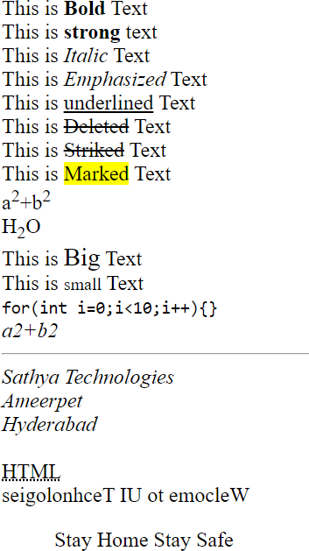

Paragraphs in HTML
Inline Elements
PARAGRAPHS

Converting Block Level Elements to Inline Elements
Converting Inline Elements to Block Level Elements
Margin in CSS
Box Model in CSS
Paragraphs
<p></p> tag, used to display paragraphs
<p></p> tag also block level element
Inline Elements
each element never starts with the new line (Inline elements displays horizontally)
Converting Block Level Elements to Inline Elements in CSS
Below snippet used to convert block level elements to inline elements
Ex.
display: inline-block;
Converting Inline Elements to Block Level Elements in CSS
Below snippet used to convert inline elements to block level elements
Ex.
display: block;
Margin in CSS
space around the element called as margin

Ex.

box-model in CSS

margin: 20px

combination of padding, border and margin called as box-model in CSS
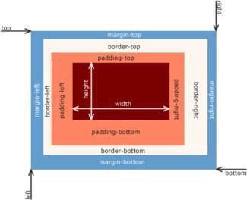
Example:
paragrahs.html
<!DOCTYPE html>
<html>
<head>
<title>Paragraphs</title>
<link rel="stylesheet" href="paragraphs.css">
</head>
<body>
<p>
Lorem ipsum dolor sit amet consectetur adipisicing elit. Magnam cum numquam, ab blanditiis laudantium nemo odit perspiciatis officia itaque tenetur ut. Natus praesentium dolore magnam.
</p>
<p>
Lorem ipsum dolor sit amet consectetur adipisicing elit. Magnam cum numquam, ab blanditiis laudantium nemo odit perspiciatis officia itaque tenetur ut. Natus praesentium dolore magnam.
</p>
<p>
Lorem ipsum dolor sit amet consectetur adipisicing elit. Magnam cum numquam, ab blanditiis laudantium nemo odit perspiciatis officia itaque tenetur ut. Natus praesentium dolore magnam.
</p>
</body>

</html> paragraphs.css p{
border: 1px solid red; width: 20%;
display: inline-block; padding: 20px; margin: 20px; border-radius: 20px; text-align: justify;
font-family: Comic Sans MS; color: white;
background: linear-gradient(45deg,red,black);
}
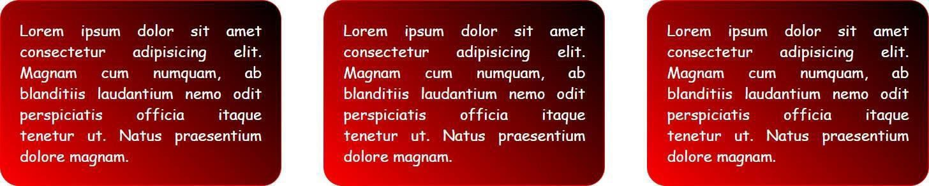
Output

divisions in html
internal CSS
DIVISIONS

differences between internal CSS and external CSS
selectors
class selector
id selector
element selector
universal selector
differences between class selector and id selector
divisions in html
Divisions are used to divide webpage into multiple sections
<div></div> tag used to create divisions in webpages
<div></div> tag also block level element

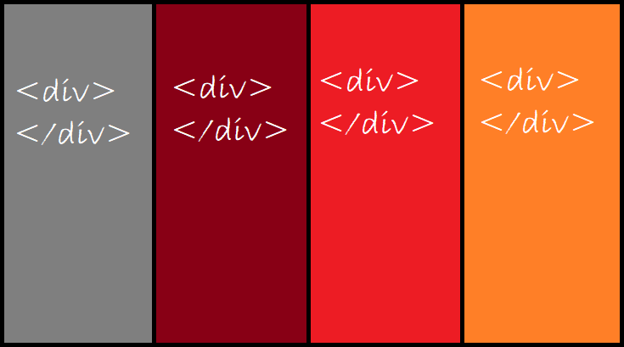
internal CSS
<style></style> tag used to write internal CSS
differences between internal CSS and external CSS
Internal CSS | External CSS
<style></style> tag used to write the internal CSS | <link> tag, used to include the external CSS
<style></style> tag is paired tag | <link> tag is non paired tag
we can achieve CSS reusability through external CSS | we can't reuse CSS through internal CSS

selectors
Selector "Selects" Particular "HTML Elements" to apply CSS
Types of Selectors
class selector
id selector
element selector / tag selector
universal selector
class selector
class selector should start with "." (dot)
Syntax
HTML CSS
***** ***
<div class="c1"> .c1{
</div> }

id selector
id selector should start with "#"
Syntax
HTML CSS
***** ***
<div id="id1"> #id1{
</div> }

element selector
element selector starts with "tag" name
Syntax
HTML CSS
***** ***
<div> div {
</div> }

universal selector
we will represent "universal selector" with "*"
CSS applied to "all elements" through "universal selector"

differences between class selector and id selector
Class selector | Id selector
class selector starts with . (dot) | id selector starts with "#"
we may duplicate class | Id should be unique
we can apply more than one class Ex.  <div class="c1 c2 c3">  </div> | we can apply only one id Ex.  <div id="id1">  </div>
class selector has less priority compared to id selector  (specificity) | id selector has more priority compared to class selector  (specificity)
if a greater number of teams working on same project, then class selector  is suggested | to override 3rd party CSS then we will use id selector

Example divisions.html
<!DOCTYPE html>
<html>
<head>
<title>Divisions</title>
<style> div{
border: 1px solid gray; width: 25%;
display: inline-block; padding: 10px; margin: 10px; border-radius: 20px;
}
h1{
color: red;
text-align: center;
}
p{
text-align: justify;
font-family: Comic Sans MS; color: white;
}
.c1{
background: linear-gradient(90deg,green,yellow);
}
#id1{
background: linear-gradient(90deg,pink,yellow);
}
#id2{
background: linear-gradient(90deg,black,blue);
}
</style>
</head>
<body>
<div class="c1">
<h1>HTML</h1>
<p>

Lorem ipsum dolor, sit amet consectetur adipisicing elit. Aperiam alias esse ducimus, atque quidem exercitationem saepe. Maiores fugit praesentium mollitia iste magnam sunt earum facilis?
</p>
</div>

<div id="id1">
<h1>CSS</h1>
<p>
Lorem ipsum dolor, sit amet consectetur adipisicing elit. Aperiam alias esse ducimus, atque quidem exercitationem saepe. Maiores fugit praesentium mollitia iste magnam sunt earum facilis?
</p>
</div>
<div id="id2">
<h1>JAVASCRIPT</h1>
<p>
Lorem ipsum dolor, sit amet consectetur adipisicing elit. Aperiam alias esse ducimus, atque quidem exercitationem saepe. Maiores fugit praesentium mollitia iste magnam sunt earum facilis?
</p></div></body>
</html>

Output
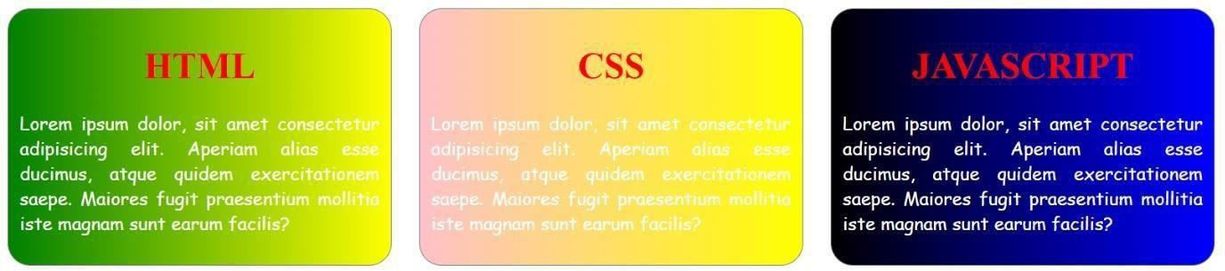

Buttons, span, images and Inline CSS

Button
applying css to webpages
CSS Specificity (Priority)
Span
Images
Hover in CSS Button
<button></button> tag used to display Buttons in webpages
<button></button> tag is inline element Ex.
<button>
Login
</button>
Example buttons.html
<!DOCTYPE html>
<html>
<head>
<title>Buttons</title>
</head>
<body>
<button style="width: 100px; height: 100px; background-color: yellow; color: red;
border: 1px solid red; border-radius: 20px;">
Button1
</button>
<button style="width: 100px; height: 100px;
background-color: orangered; color: white;
border: 1px solid yellowgreen; border-radius: 20px;">
Button2
</button>
</body>
</html>
Output:

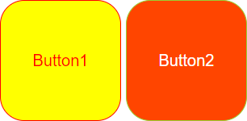
applying css to webpages
we can apply css to webpages in three ways
external css
internal css
inline css
external css
<link> tag used to include the external css
through external css we can achieve css reusability
internal css
<style></style> tag used to write the internal css through internal css we can't reuse the css
inline css
style attribute used to apply the inline css through "inline css" also we can't reuse the css

CSS Specificity (Priority)
CSS priorities are defined below like this

Ex. span
inline > id > class > element
wrap particular "content" from "text", we will use span
<span></span> tag is inline element
<span></span> tag used to display validation messages

Example span.html
<!DOCTYPE html>
<html>
<head>
<title>SPAN</title>
</head>
<body>
<p>
welcome to <span style="color: red;">ui</span> technologies
</p>
</body>
</html>
Output

Images
<img> tag used to display the images
<img> tag is non paired tag
<img> tag is inline element Attributes
width
used to define image width
height
used to define image height

src
alt

Example Images.html
refers image page

whenever image displays fail automatically alternative text will display

<!DOCTYPE html>
<html>
<head>
<title>Images</title>
<style>
img{
margin: 20px;
border: 2px solid blue;
}
.c1:hover{ width: 200px; height: 150px;
border: 2px solid red;
}
.c2:hover{ height: 150px;
border-radius: 100%; border-color: green;
}
.c3:hover{ display: none;
}
</style>
</head>
<body>
<img width="150px" height="100px" src="flipkart.png" alt="Error" class="c1">
<img width="150px" height="100px" src="amazon.png" alt="Error" class="c2">
<img width="150px" height="100px" src="myntra.png" alt="Error" class="c3">
</body>
</html> Output:

Hover
Hover is a pseudo class in css
Whenever mouse over a particular element automatically hover effect will execute
Syntax
.c1: hover {
//css code
}

#id1: hover {
//css code
}
Img: hover {
//css code
}
Hyperlinks, FieldSet, Marquee, TextFormating Tags

Hyperlinks
Fieldset
Marquee Hyperlinks
<a></a> tag used to create the hyper links
<a></a> tag used to navigate from one web page to another Webpage
<a></a> tag also used to send emails
<a></a> tag also used to open the external websites
<a></a> tag is inline element Attributes
href
used to link the path of "target resource"
target="_blank"
used to open the "new tab" in browser
Example1:
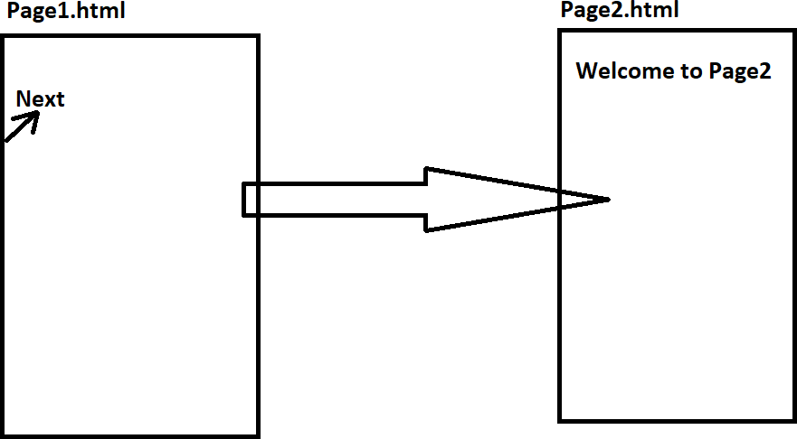
Code 1.html
<!DOCTYPE html>
<html>
<head>
<title>Anchor</title>
</head>
<body>
<a href="page2.html" target="_blank"> Next
</a>
</body>
</html>
page2.html
<!DOCTYPE html>
<html>
<head>
<title>Page2</title>
</head>
<body>
<h1>Welcome to Page2... !</h1>
</body>
</html>

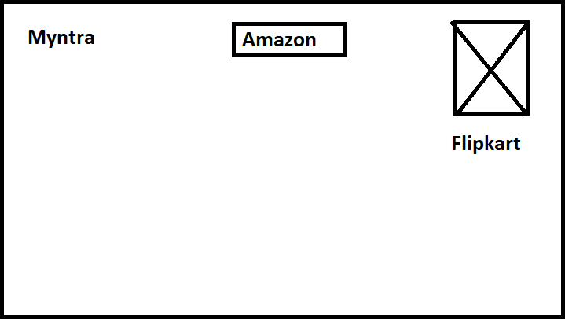
Example2:
Example
<!DOCTYPE html>
<html>
<head>
<title>Websites Example</title>
</head>
<body>
<a href="https://www.myntra.com/" target="_blank" style="margin: 40px;">
Myntra
</a>
<a href="https://www.amazon.in/" target="_blank" style="margin: 20px;">
<button>Amazon</button>
</a>
<a href="https://www.flipkart.com/" target="_blank">
<img width="50px" height="50px" src="flipkart.png" alt="Error">
</a>
</body>
</html>
Fieldset
this tag used to create rectangular structures Ex.
<fieldset>
<legend>LOGIN FORM</legend>

</fieldset> Example: fieldset.html
<!DOCTYPE html>
<html>
<head>
<title>Fieldset</title>
<style>
fieldset{ width: 25%;
border-color: red; border-radius: 20px;
}
legend{
background-color: yellow; color: red;
padding: 5px; border: 2px solid red; border-radius: 20px;
}
p{
text-align: justify;
font-family: Comic Sans MS; color: red;
}
</style>
</head>
<body>
<fieldset>
<legend>LOGIN FORM</legend>
<p>
Lorem, ipsum dolor sit amet consectetur adipisicing elit. Possimus, quaerat tenetur debitis libero et sequi doloremque ratione aperiam fugiat cum. Praesentium, fugiat. Voluptates, deleniti. Omnis!
</p>
</fieldset>
</body>
</html>
Output:

TABLES
- collection of rows and columns called as table

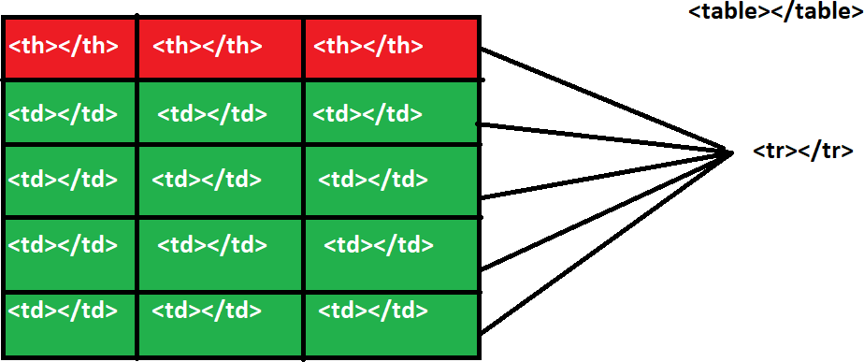

TAGS
- <table></table> tag used to create the tables
- <tr></tr> tag used to create table row
- <th></th> tag used to display table heading
- <td></td> tag used to display cell data

Attributes
- border
it is used to draw the border to the table Ex.
border="1"

- align="left"/"center"/"right"
it is used to align the table default value is "left"

- cellspacing
it is used to maintain space between cells Ex.
cellspacing="10px"
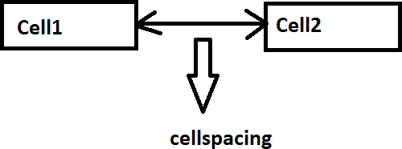

- cellpadding
space around cell content called as cellpadding Ex.
cellpadding="10"
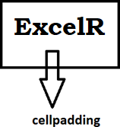

- colspan

it is used to merge the cells horizontally Ex.

colspan="2"

- rowspan

it is used to merge the cells vertically Ex.

rowspan="2"
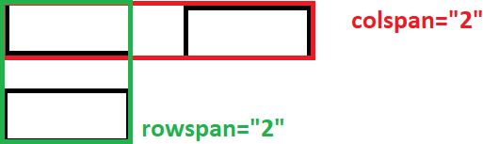
Examples
******** table1.html
<!DOCTYPE html>
<html>
<head>
<title>Tables</title>
</head>
<body>
<table border="1"
align="center" cellspacing="20px" cellpadding="20px">

<tr>
<th>E_ID</th>
<th>E_NAME</th>
<th>E_SAL</th>
</tr>
<tr>
<td>111</td>
<td>E_ONE</td>
<td>10000</td>
</tr>
<tr>
<td>222</td>
<td>E_TWO</td>
<td>20000</td>
</tr>
<tr>
<td>333</td>
<td>E_THREE</td>
<td>30000</td>
</tr>
<tr>
<td>444</td>
<td>E_FOUR</td>
<td>40000</td>
</tr>
<tr>
<td>555</td>
<td>E_FIVE</td>
<td>50000</td>
</tr>
</table>
</body>
</html>

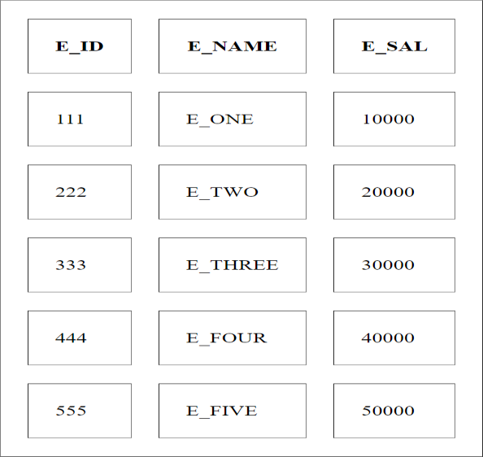
Output:
table2.html
<!DOCTYPE html>
<html>
<head>
<title>TABLES</title>
</head>
<body>
<table border="1"
align="center" cellspacing="10px" cellpadding="10px">
<tr>
<th>P_ID</th>
<th>P_NAME</th>
<th>P_COST</th>
<th>P_IMAGE</th>
<th>UPDATE</th>
<th>DELETE</th>
</tr>
<tr>
<td>111</td>
<td>P_ONE</td>
<td>10000</td>
<td>
<img src="flipkart.png" width="100px" height="100px" alt="Error">
</td>

<td>
<button>UPDATE</button>
</td>
<td>
<button>DELETE</button>
</td>
</tr>
<tr>
<td>222</td>
<td>P_TWO</td>
<td>20000</td>
<td>
<img width="100px" height="100px" src="amazon.png" alt="Error">
</td>
<td>
<button>UPDATE</button>
</td>
<td>
<button>DELETE</button>
</td>
</tr>
<tr>
<td>333</td>
<td>P_THREE</td>
<td>30000</td>
<td>
<img width="100px" height="100px" src="myntra.png" alt="Error">
</td>
<td>
<button>UPDATE</button>
</td>
<td>
<button>DELETE</button>
</td>
</tr>
</table>
</body>

</html>
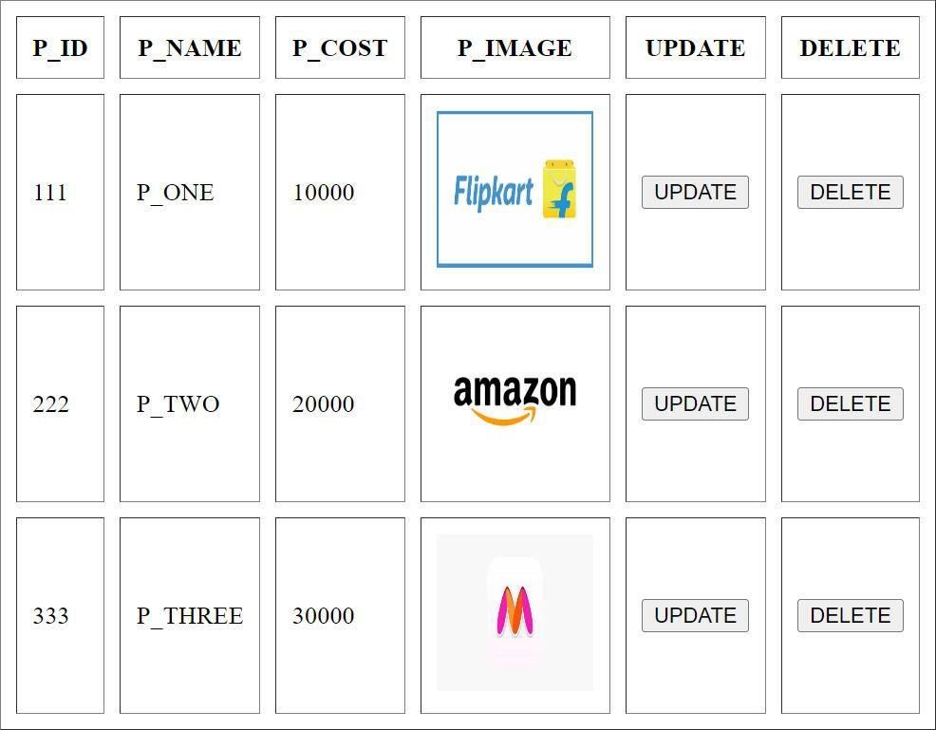
Output:

tables3.html
<!DOCTYPE html>
<html>
<head>
<title>TABLES</title>
<link rel="stylesheet" href="https://cdnjs.cloudflare.com/ajax/libs/font- awesome/4.7.0/css/font-awesome.min.css">
</head>
<body>
<table border="1"
align="center" cellspacing="10px" cellpadding="10px">
<tr>
<th>NAME</th>
<th>DELETE</th>
<th>UPDATE</th>

</tr>
<tr>
<td>LAPTOP</td>
<td>
<i class="fa fa-trash"></i>
</td>
<td>
<i class="fa fa-edit"></i>
</td>
</tr>
<tr>
<td>WATCH</td>
<td>
<i class="fa fa-trash"></i>
</td>
<td>
<i class="fa fa-edit"></i>
</td>
</tr>
<tr>
<td>
MOBILE
</td>
<td>
<i class="fa fa-trash"></i>
</td>
<td>
<i class="fa fa-edit"></i>
</td>
</tr>
</table>
</body>
</html> Output
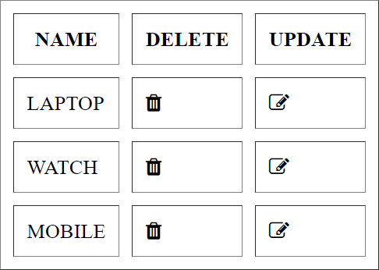

table4.html
<!DOCTYPE html>
<html>
<head>
<title>TABLES</title>
</head>
<body>
<table border="1"
align="center" cellspacing="10px" cellpadding="10px">
<tr>

E_DEPT</th>
<th>E_ID</th>
<th>E_NAME</th>
<th>E_SAL</th>
<th colspan="2">E_DESIGNATION &

</tr>
<tr>

<td>E101</td>
<td>E_ONE</td>
<td>10000</td>
<td>Jr Engg</td>
<td rowspan="2">CSE <br> IT</td>
</tr>
<tr>
<td>E102</td>
<td>E_TWO</td>
<td>20000</td>
<td>Sr Engg</td>
</tr>
<tr>
<td colspan="3">E103 & E_THREE &30000</td>
<td rowspan="3">Team Lead <br><br> Manager
<br><br> Sr Manager</td>
<td>ECE</td>
</tr>
<tr>
<td>E104</td>
<td>E_FOUR</td>
<td>50000</td>

<td>MECH</td>
</tr>
<tr>
<td>E105</td>
<td>E_FIVE</td>
<td>50000</td>
<td>EEE</td>
</tr>
</table>
</body>
</html> Output
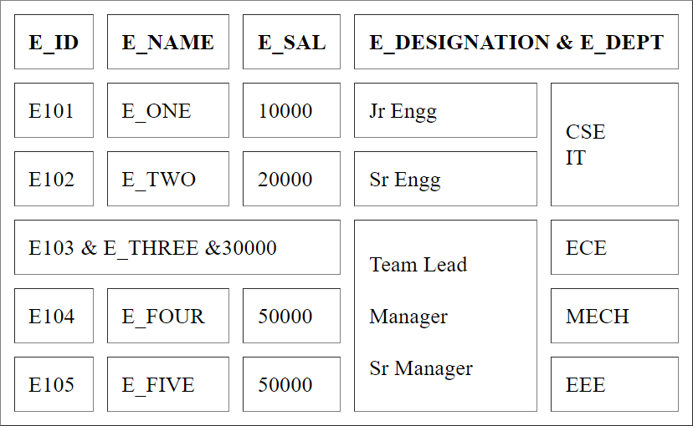
tables5.html
<!DOCTYPE html>
<html>
<head>
<title>TABLES WITH CSS</title>
<style>
table{
width: 100%;
text-align: center; border: 1px solid gray; border-collapse: collapse;
}

th,td{
border: 1px solid gray;

}
th{
}
td{
}
height: 50px; height: 30px;

tr:nth-child(even){ background-color: yellow; color: red;
}
tr:nth-child(odd){ background-color: orange; color: white;
}
tr:hover{
background-color: burlywood;
}
</style>
</head>
<body>
<table>
<tr>
<th>SNO</th>
<th>SNAME</th>
<th>CLASS</th>
</tr>
<tr>
<td>1</td>
<td>SONE</td>
<td>DBatch</td>
</tr>
<tr>
<td>2</td>
<td>STWO</td>
<td>CBatch</td>
</tr>
<tr>
<td>3</td>

<td>STHREE</td>
<td>BBatch</td>
</tr>
<tr>
<td>4</td>
<td>SFOUR</td>
<td>ABatch</td>
</tr>
</table>
</body></html>
